NEURALSEEK
AI Tuning & Guardrails
Configuration reference for tuning answer quality and applying governance to user input and generated output.
DOCUMENT NeuralSeek Configure Tab Reference
AUDIENCE Administrators, Subject-Matter Experts, Solutions Engineers
STRUCTURE Part 1 covers AI tuning. Part 2 covers guardrails.

Part 1 — AI Tuning
These settings shape how NeuralSeek connects to your data, ranks documents, and generates answers. Tuning these correctly is the foundation of high-quality output before guardrails are layered on.

Overview
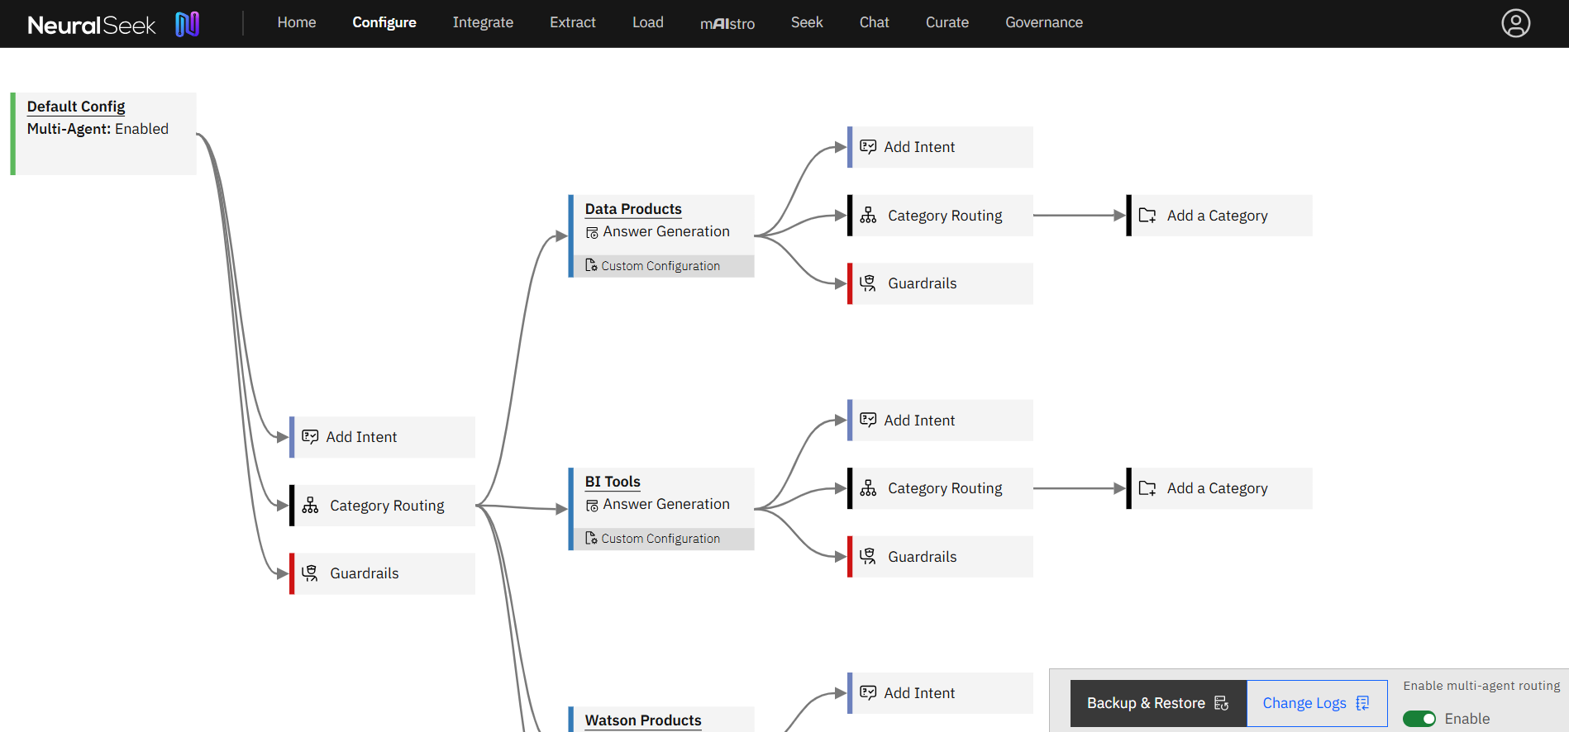
Figure: configure
What is it?
- The Configure tab allows users to modify settings for NeuralSeek features.
Why is it important?
- This functionality allows for a highly customizable and adaptable user experience, enabling organizations to optimize the performance of NeuralSeek in accordance with their unique use cases. Whether it involves adjusting default configurations for standard use or delving into advanced configurations for more nuanced preferences, the "Configure" tab empowers users to fine-tune NeuralSeek's capabilities. This level of customization ensures that NeuralSeek becomes a versatile and effective tool, capable of delivering optimal results across diverse organizational contexts.
How does it work?
- For more information on each level in the Configure tab, refer to the Configuration Details outlined below.

Multi-Agent Routing
Enable NeuralSeek's Multi-Agent Routing in the bottom right corner of the Configure tab. This will allow users to connect different configurations based on defined categories of user queries and handle the interactions dynamically and more effectively.
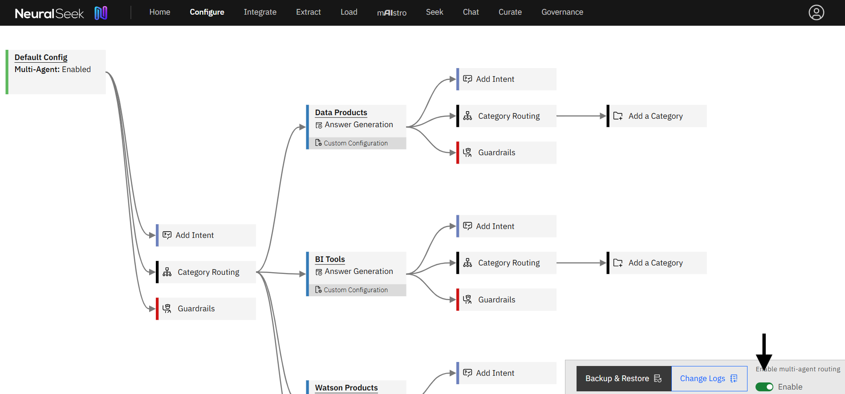
Figure: multi-agent-routing
With Multi-Agent Routing, configuration nodes flow through a tree with defined categories. Categories are used to drive the path of the multi-agent flow. At each category in the tree you can specify a custom configuration that will be used by it and nested levels beneath it. Upon adding a custom configuration, a new node will appear labeled Guardrails that allow users modify essential guardrails for the newly defined category.
NOTE
Newly defined categories will automatically utilize the Default Configuration settings and Guardrails. From a default configuration, you can save a proposal to be utilized, or edit a category to utilize a custom configuration with custom guardrails.
EXAMPLE — Answer Generation Example
A category can be driven with an Answer Generation action.
- Click on the Add A Category node.
- Select Answer Generation as the action to take upon match.
- Add a relevant Category Name and a brief Category Description.
- Click Save Category. A new branch will appear in the Multi-Agent Routing tree.
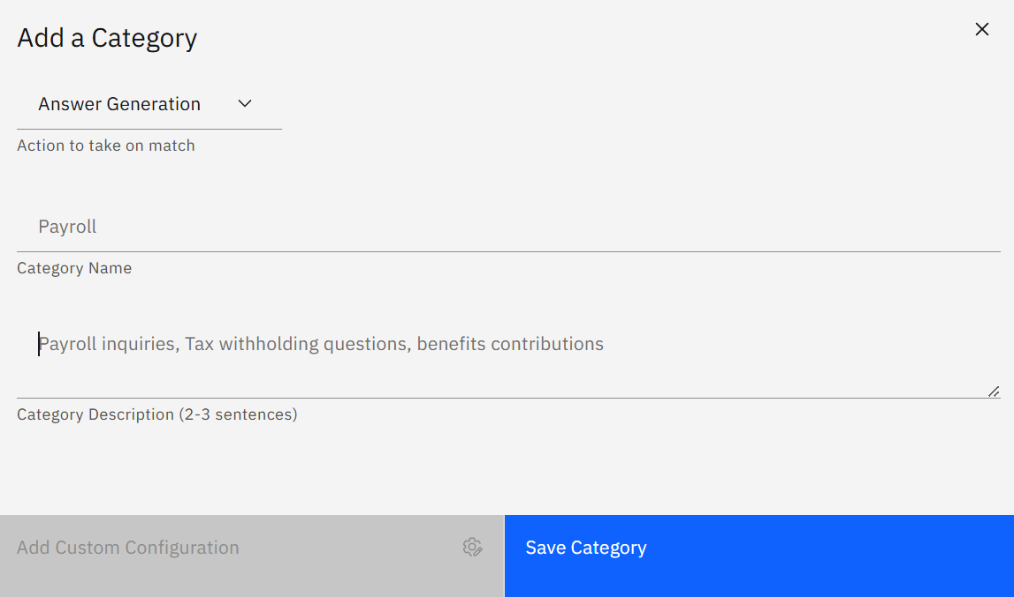
Figure: MAR new category
New categories will utilize the Default Configuration settings defined in the first node of the Multi-Agent Routing tree, also labled the Default Config node.
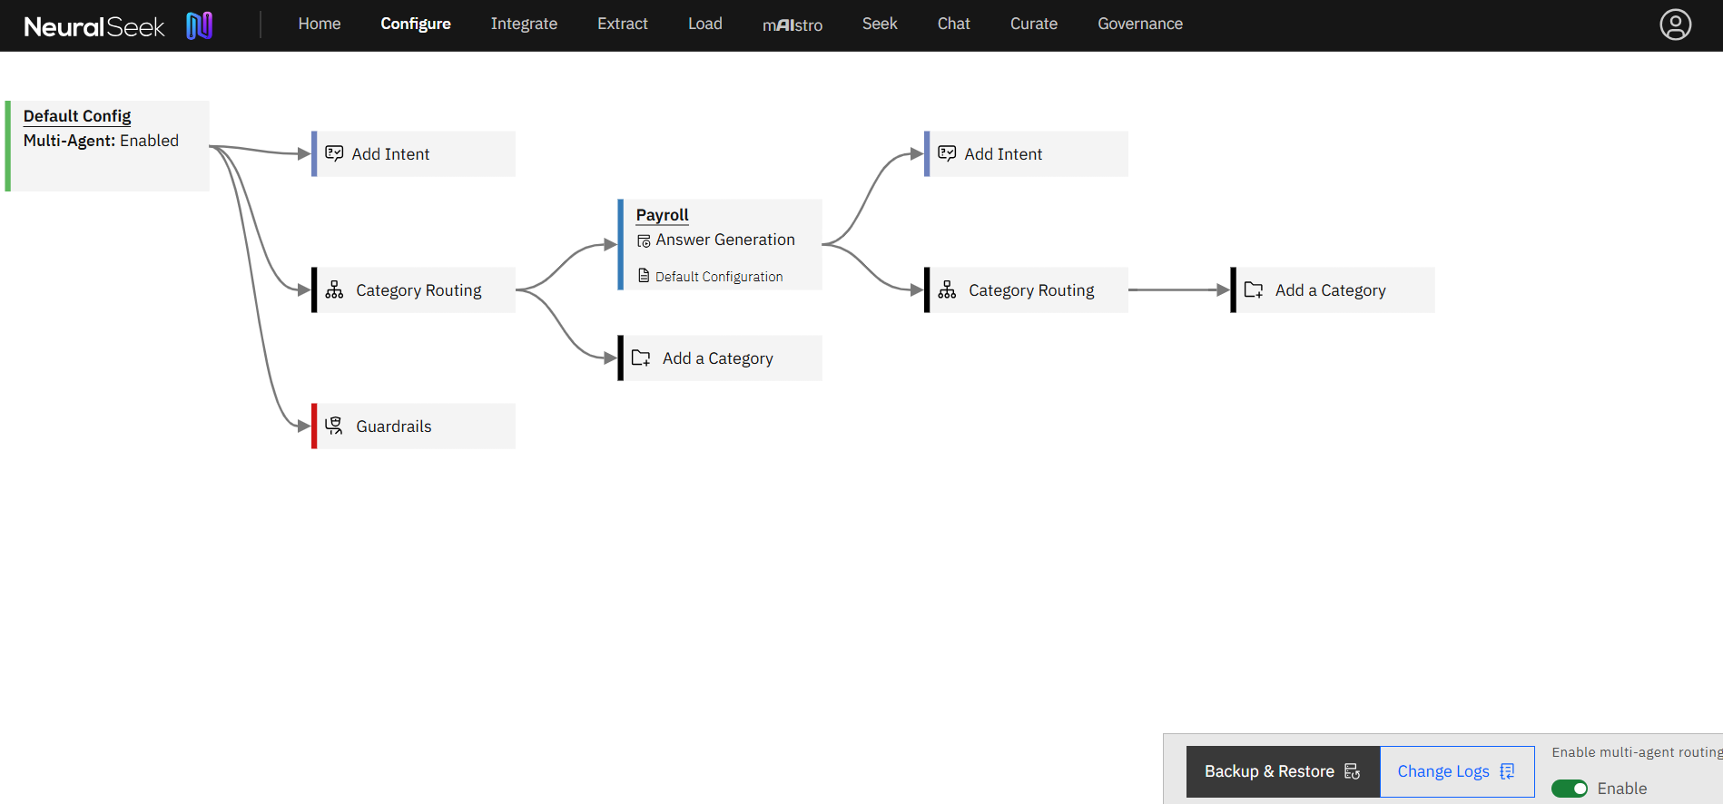
Figure: default config
To edit a Custom Configuration for the newly defined category:
- Click on the category node.
- Click Add Custom Configuration
- The familiar NeuralSeek Configuration panel will pop up. Save your changes for your custom configuration and notice the category is now defined with a Custom Configuration.
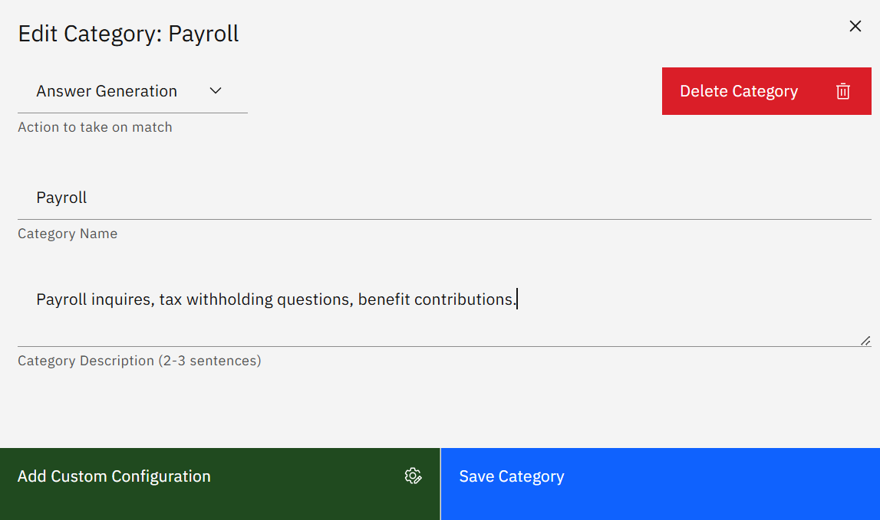
Figure: MAR add custmom config
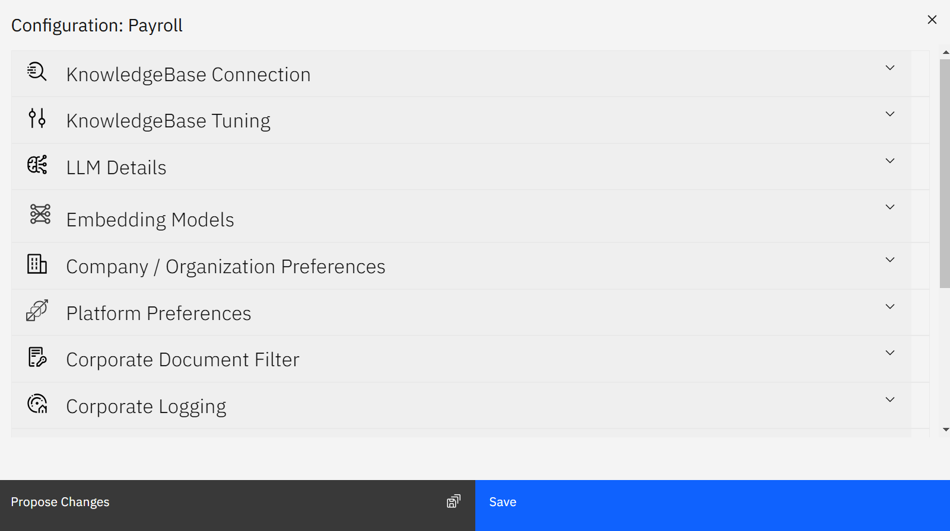
Figure: MAR NS config panel
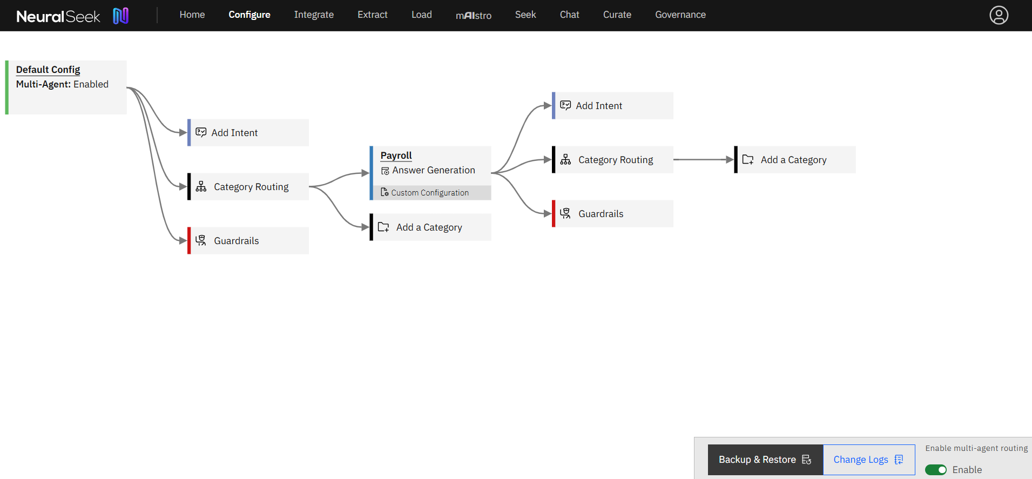
Figure: custom config
EXAMPLE — mAIstro-led Example
A category can be driven with a mAIstro-led action.
- Click on the Add A Category node.
- Select mAIstro-led as the action to take upon match.
- Add a relevant Category Name and a brief Category Description.
- Click Save Category. A new branch will appear in the Multi-Agent Routing tree.
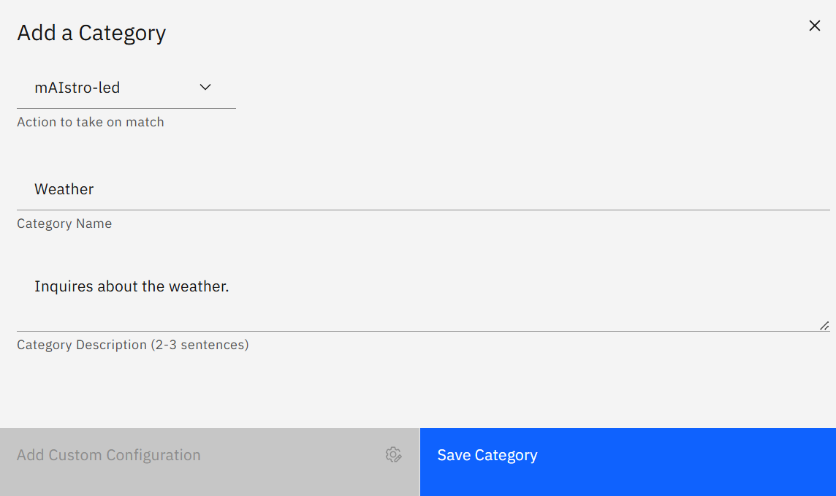
Figure: MAR new maistro led
New categories will utilize the Default Configuration settings defined in the first node of the Multi-Agent Routing tree, also labled the Default Config node. This configuration can be edited.
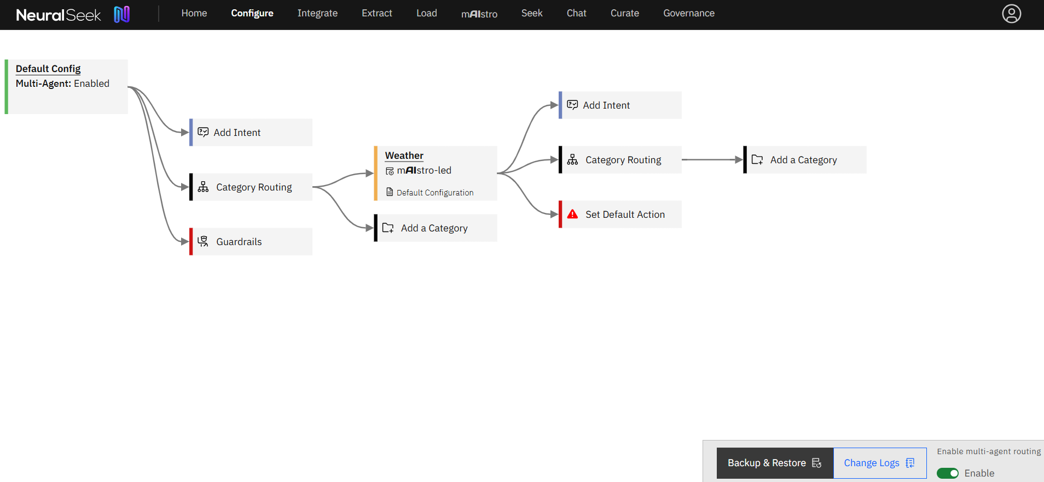
Figure: maistro led config
Select your mAIstro agent by clicking Set Default Action and selecting from the drop-down menu.
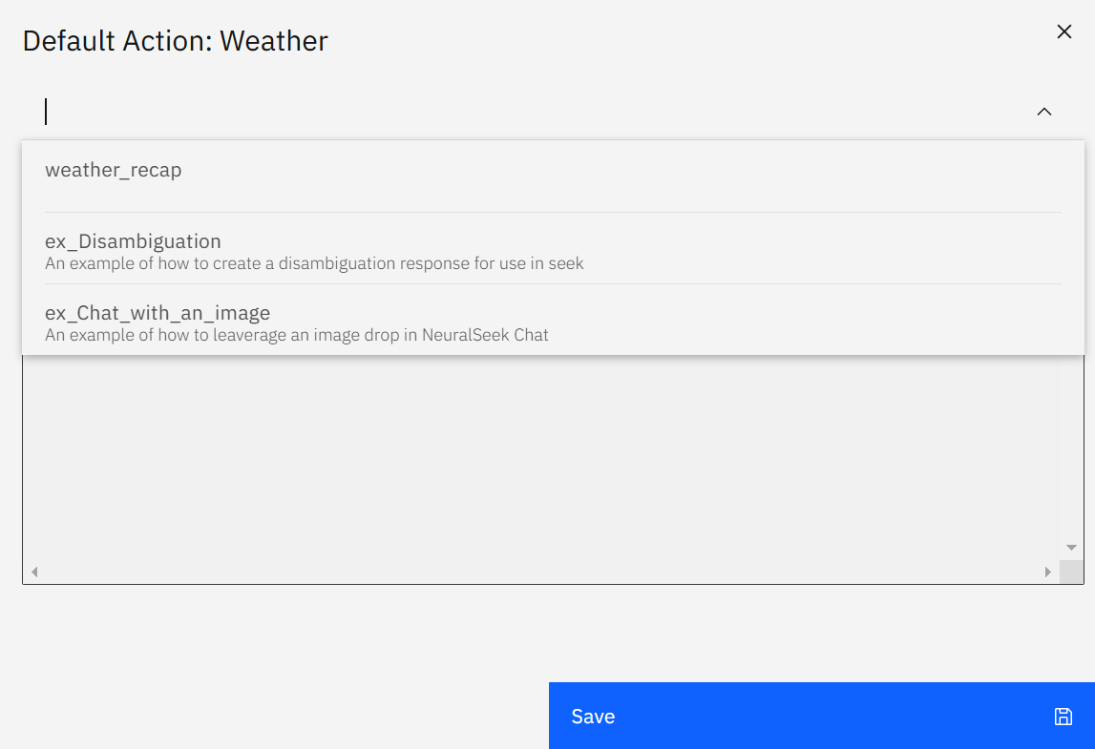
Figure: MAR maistro agent
TIP
For the mAIstro agent to appear in the drop-down menu, edit the mAIstro agent to begin with a Seek - In node. Save the agent with a unique name.

Configuration Details
This location of NeuralSeek is where users can edit the configurations for NeuralSeek's features.

KnowledgeBase Connection
Users can change their KnowledgeBase type along with the associated URL, API keys, project ID, and other relevant information. Use the dropdown arrows to manually configure the fields of the schema in the connected KnowledgeBase.
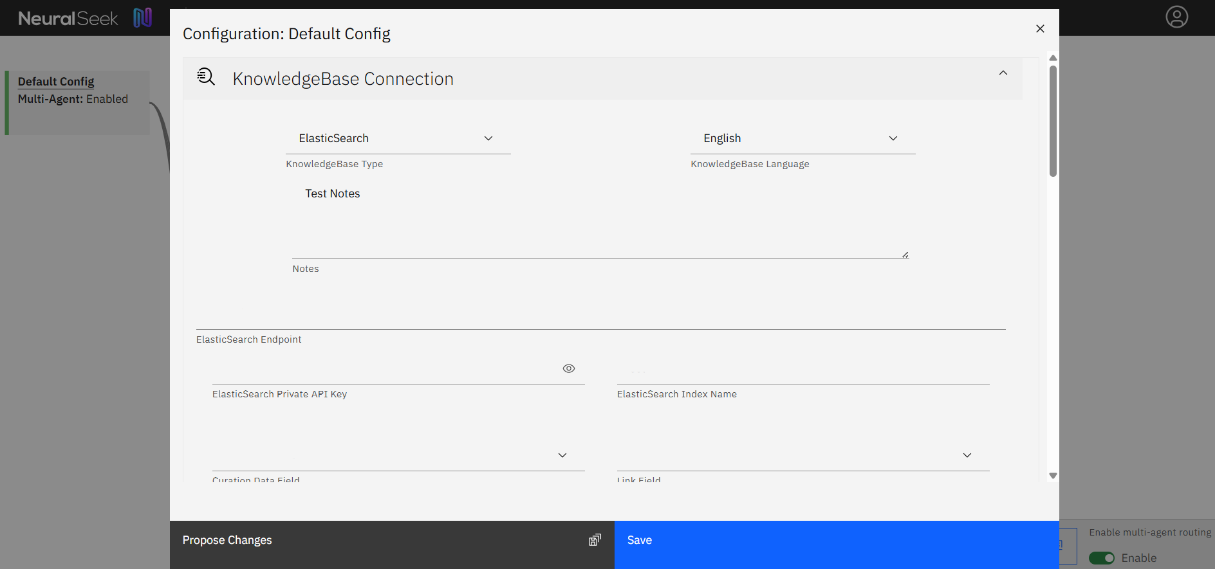
Figure: knowledgebase connection
REFERENCE — Values
- KnowledgeBase Type: The KnowledgeBase provider.
- KnowledgeBase Language: The language of documents loaded into the selected KnowledgeBase.
- Notes: Optionally, add any notes related to the selected KnowledgeBase configuration.
- Curation Data Field: Select the parameter of your FAQ content/document body.
- Link Field: Select the URL field from the document metadata - shown below the title, or served in the Virtual Agent chat bubble as a link.
- Document Name Field: The document metadata field for document "Title".
- Additional Payload Field Allows users to add additional data into their message.
- Attribute sources inside LLM Context by Document Name: Users have the option to enable or disable attributing sources inside LLM context by document name. For example, when disabled the output will be formatted with only the document contents. When enabled, the output will be formatted with an introductory sentence that attributes the 'document content' to the appropriate document 'name' (e.g. The document 'name' states that: 'document content'). This helps some LLMs follow the track of information.
- Return the document instead of passages (only enable this if all of your documents are short) Users can enable return the document instead of passages in order to get an output that is a full document. This should only be enabled if all of the documents in the search are short.
- Filter Field: Select document metadata field to use for filtering. For example, you can filter on a 'document_type' field for only 'PDF' types.
- Static Default Filter Value (when no runtime filter is passed) The value a filter uses as its default setting. This value can differ when a runtime filter is passed.
- Re‑Sort Values List: Users can enter a prioritized list of values that will re‑rank documents and URLs above other results, regardless of KB score. Click the light bulb icon to add a new row and enter the priority value.
INFO — How to Use Re‑Sort Values
1. Go to KnowledgeBase → Connection Settings. 2. Click the light bulb icon to add a new Re‑Sort value (e.g., priority-topic or critical-url). 3. Tag relevant documents or URLs in your KnowledgeBase with this value. 4. Run a Seek query to verify that items with this value appear higher in the results.
- Enable Advanced Schema Enabling Advanced Schema allows users to get a more narrow search based on the Value List inputs.

KnowledgeBase Tuning
Tuning your KnowledgeBase is an important part of creating a well performing system.
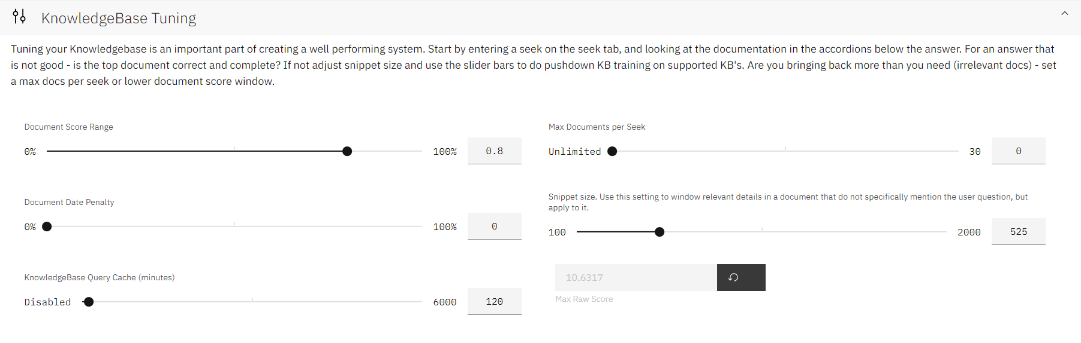
Figure: knowledgebase tuning
REFERENCE — Values
- Document Score Range: The upper range score of documents to return. E.g. when set to 0.8 or 80%, return the top scoring 80% of documents, discarding the lowest 20% scored documents. The smaller the number, the more strict the score threshold will be. Generally best set to a high number, used with Max Docs setting.
- Document Date Penalty: Penalize document scores that include old dates. A higher number means a higher penalty for older documents, scaling with time/age.
- KB Query Cache: Limit repeated queries to the KnowledgeBase by caching KB queries. Set this to the number of minutes you'd like to preserve cached KB queries.
- Max Documents per Seek: The number of documents to send to the LLM on each Seek action. Generally the best results are seen with this set to 4-5 documents.
- Snippet Size: The character count to pass to the KB for document passage size. The larger the number, the bigger the documentation chunk. Generally best as a smaller number - around 500.
- Max Raw Score: The highest all-time document score NeuralSeek has seen from the KB. NeuralSeek uses this number internally to calculate a 100% score for documents.

Hybrid & Vector Search Settings
Offering the ability to choose from searching with Lucene, Vector, or a Hybrid approach
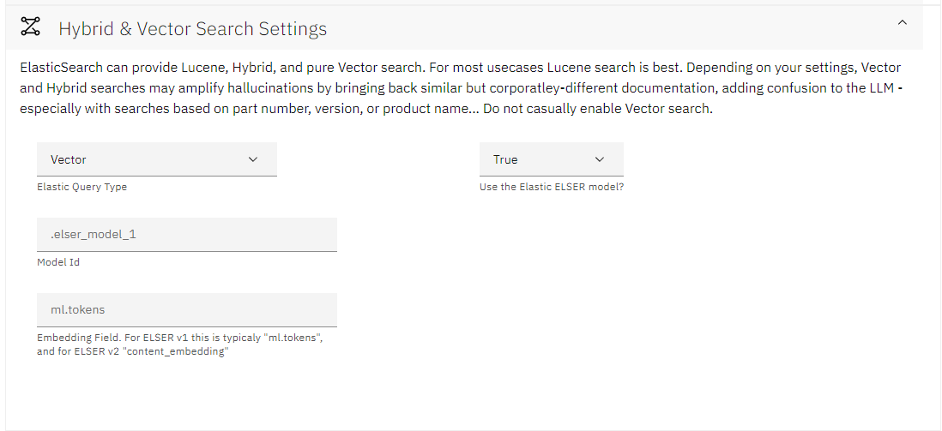
Figure: vector settings
REFERENCE — Values
- Query Type: The type of query that NeuralSeek will use to gather source documentation.
- Lucene: "Exact match" queries.
- Vector: Vector similarity search, based on your deployed Vector model.
- Hybrid: A combined search query that slightly boosts Lucene results, allowing for graceful fallback to Vector results if no exact matches are found.
- Use the Elastic ELSER model? The query format is different using ELSER vs deployed KNN models. Select False if not using Elastic's ELSER model.
- ELSER - Model ID: The name of the deployed and running model.
- ELSER - Embedding Field: The name of the metadata field where the generated Vector embeddings are stored.
- Elastic KNN Query: The JSON of the KNN Vector query to run. There are a couple values to set within the JSON:
- field: The name of the metadata field where the Vector embeddings are stored.
- model_id: The name of the deployed and running model.
- model_text: We offer a << query >> expansion variable to insert the query generated by NeuralSeek. Useful to edit if some Vector models require a specific format, e.g. question: <<query>>
- See the Elastic documentation for more info around the other available parameters.

LLM Details
This is where users can add a LLM of choice, and set or modify their LLM model settings. By clicking "Add an LLM", users will be prompted to select an LLM from their platform of choice and enter the relevant information such as API keys, endpoint URLs, project ID's, etc. Use the dropdown arrow to enable languages of choice: there are a total of 56 supported LLM languages. Users can also modify which NeuralSeek functions to enable for the added LLM. Note that you must add at least one LLM. If you add multiple, NeuralSeek will load-balance across them for the selected functions that have multiple LLM's. Features that an LLM are not capable of not be available for selection. If you do not provide an LLM for a function, there is no fallback and that function of NeuralSeek will be disabled.
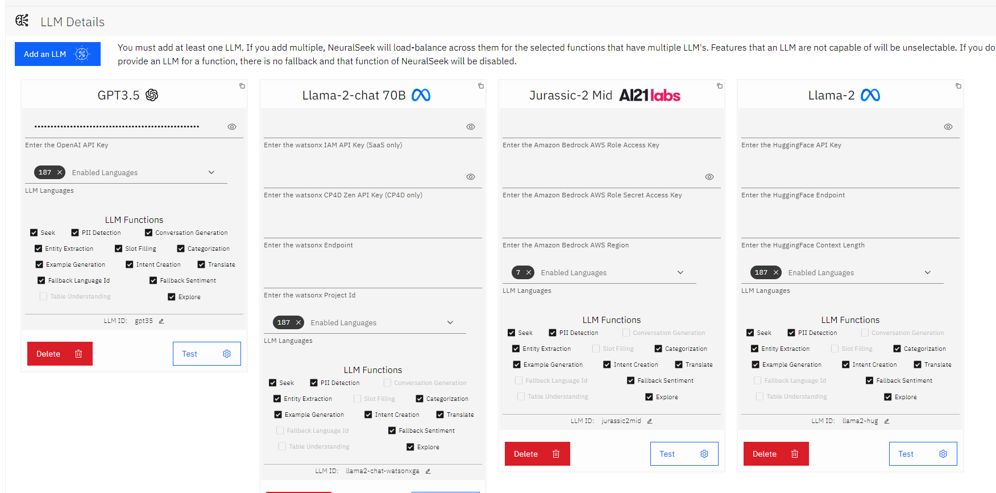
Figure: llm details
REFERENCE — Values
- API/Access Key: The LLM / Service provider's API or Access key.
- Secret/Zen Key: The Service provider's secondary key (only for some providers)
- Endpoint: The endpoint URL for the selected service.
- Region: The region where the LLM service is provisioned.
- Project Id: The project ID for the LLM workspace.
- LLLM Languages: Enable or disable specific languages to be used with the selected LLM.
- LLM Functions: Enable or disable specific functions for each LLM, essentially selecting which LLM to use for each task, or allowing load-balancing for specific tasks. E.g. one option is to use a specific LLM for seek, and a different LLM for maistro or translate, allowing for flexible and specific use cases.
- LLM ID: The ID/internal name of the selected LLM. Use this ID on API calls or from mAIstro.
- Test: Run a test completion against the LLM, verifying the credentials. This does not 'save', you must still 'save' your settings with the main UI button.
- Delete: Remove the selected LLM from the configuration.
NOTE
This section is only available if you are using BYOLLM (bring your own LLM) plan of NeuralSeek.
Not all LLM providers are equal - All options are listed here, even though your provider may not need these specific parameters.

Company/Organization Preferences
This is where you can configure your company name, and description of what the company primarily focuses on.
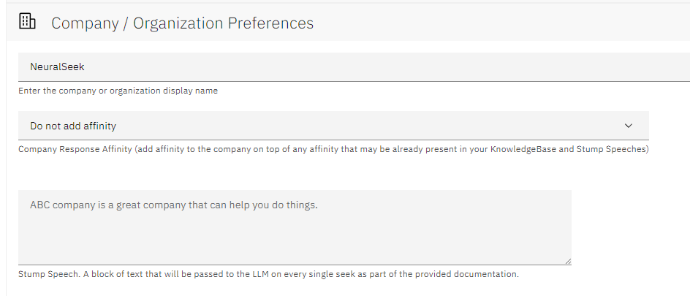
Figure: company org preferences
REFERENCE — Values
- Company or Organization Name: This field is used to help align user queries to the company KB. E.g., "How do I use your product?" will target towards this value.
- Company Response Affinity: Enable to add affinity to your company or brand in addition to existing text that may be already present in your KnowledgeBase and Stump Speeches.
- Stump Speech: Effectively an "always pinned document" that is included in the documentation for every seek call. This helps answer questions as a fallback knowledge source when the user's search fails to produce relevant documentation.

Platform Preferences
Your one-stop-shop for all platform-related preferences. Set timeouts, configure embedded links, Virtual Agent output format, etc.
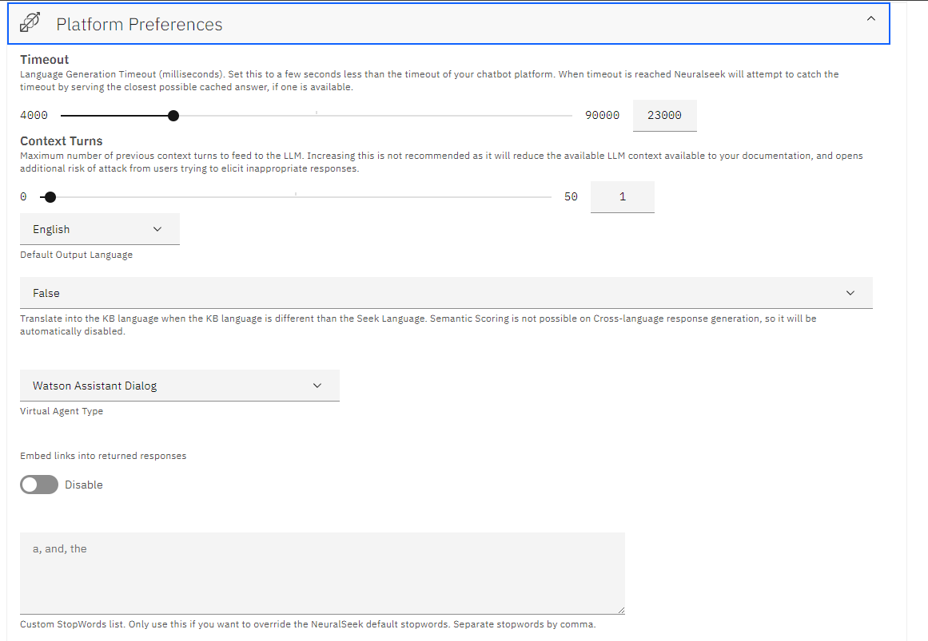
Figure: platform preference
REFERENCE — Values
- Timeout: Set this to a few seconds less than the timeout of your chatbot platform. When the timeout is reached, NeuralSeek will attempt to respond with a cached answer if available.
- Context Turns: The number of turns in the conversation to pass to the LLM. Increasing this is not recommended as it will reduce the LLM context available for your documentation.
- Context Detection: Use the model only instance for carrying language context or use the mAIstro flow for custom PoS tagging.
- Force Carry Context: If no subject or noun is found in the question, assume the question is a follow up to the previous one.
- Default Output Language: The language to reply in. Setting the language value on the API will override this parameter. Set to "Match input" to try and identify the input language and respond in that detected language.
- Cross Language: When enabled, translate queries into the language selected on the KnowledgeBase.
- Log Alternate Configs: When using seek for a Proposal or Override of the configuration, the answer should be logged in the Curate Tab.
- Hide API Keys: Hide the API keys of connected platforms from the Configure Admins. By defult, API keys are only shown to users with Admin and Configure permissions. Setting this option to true will require you to re-enter all API keys when importing a configuration file. Once set to true, this option cannot be disabled.
- Virtual Agent Type: Select the type of Virtual Agent for curation of answers. This is the format NeuralSeek will use to build the chatbot file.
- Embed Links into returned responses: Enable to embed clickable links into the seek generated answers on the API side.
- Custom Stopwords List: Stop Words - A list of "not useful" or insignificant words to remove pre-processing. Add words here to override NeuralSeek's list of stopwords.
- HTML Cleansing: Neuralseek will automatically cleanse scraped HTML pages in supported KnowledgeBases.

Corporate Document Filter
Connect NeuralSeek to an external corporate rules engine to filter allowed documentation by user. Each request will send the ID's of the found documentation to an endpoint you set here. Any IDs not returned from the corporate filter will be blocked.
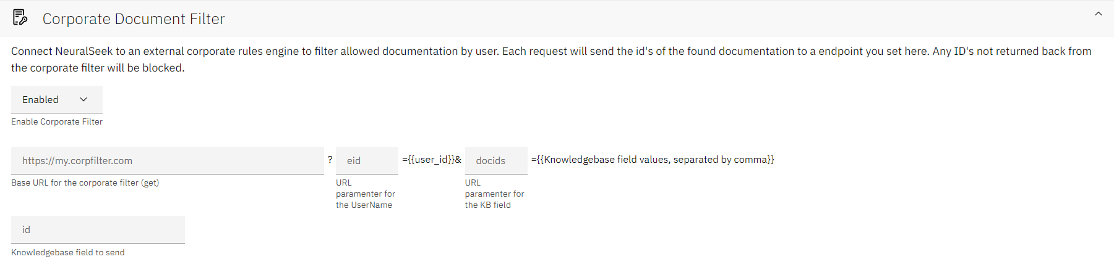
Figure: corporate doc filter
REFERENCE — Values
- Enable Corporate Filter: If enabled, fill out all relevant information including:
- Base URL for the corporate filter (get): The URL of the corporate document filter engine.
- URL parameter for the UserName: The parameter name for the user's ID.
- URL parameter for the KB field: The parameter name for the "document ID" for permission filtering.
- KnowledgeBase field to send: The KB metadata field to send as the "document ID".

Corporate Logging
Connect NeuralSeek to a corporate audit logging endpoint. When connected and enabled, all requests and responses to the Seek API endpoint, as well as the Curate tab will be logged to your Elasticsearch instance. Users are able to log the full LLM "Seek" prompt for Audit and Compliance reasons.
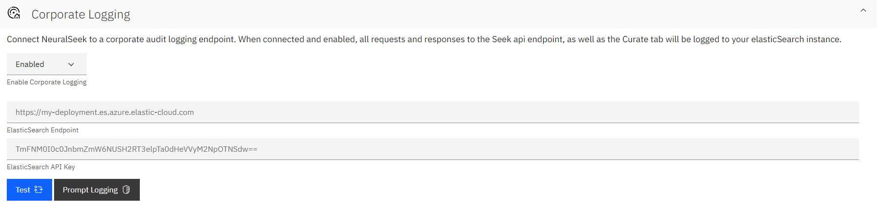
Figure: corporate logging
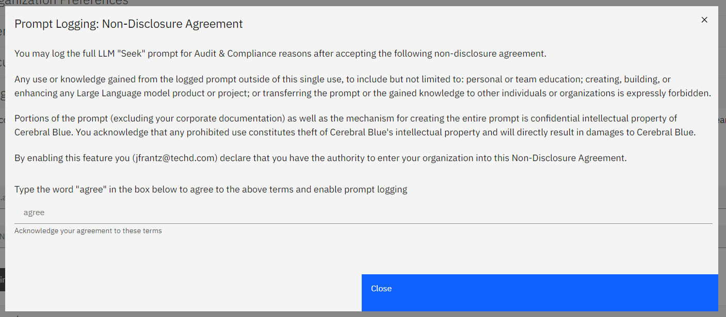
Figure: prompt logging
REFERENCE — Values
- Enable Corporate Logging: Toggle the icon to Enable or Disable this feature. If enabled, fill out all relevant information including: Elasticsearch Endpoint and Elasticsearch API Key.
- Prompt Logging: Type "agree" into the provided box to agree to the provided Non-Disclosure Agreement and enable prompt logging.

Prompt Engineering
This allows expert users to inject specific instructions into the base LLM prompt. Most use cases will not need this and should not use this. (e.g. do not enter "provide factual information" or "act as a helpful customer support agent". NeuralSeek's extensive prompting already does this.)
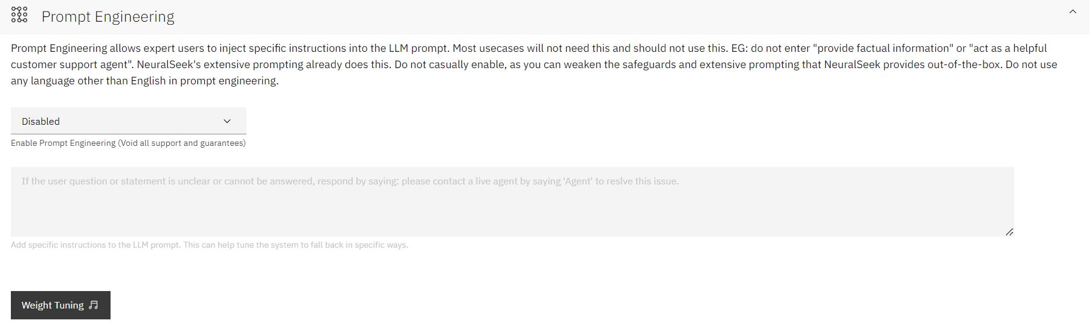
Figure: prompt engineering
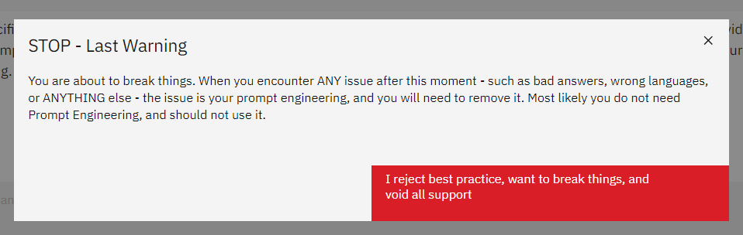
Figure: weight tuning warning
WARNING
Do not casually enable, as you can weaken the safeguards and extensive prompting that NeuralSeek provides out-of-the-box. Do not use any language other than English in prompt engineering.
REFERENCE — Values
- Prompt Instructions: Text to add to the end of the LLM prompt. This can rarely be helpful, but some examples might be "Answer with a bulleted list if possible", or "Answer in cowboy dialect".

Answer Engineering & Preferences
Customizing answer engineering and setting preferences provides adaptability to different contexts.
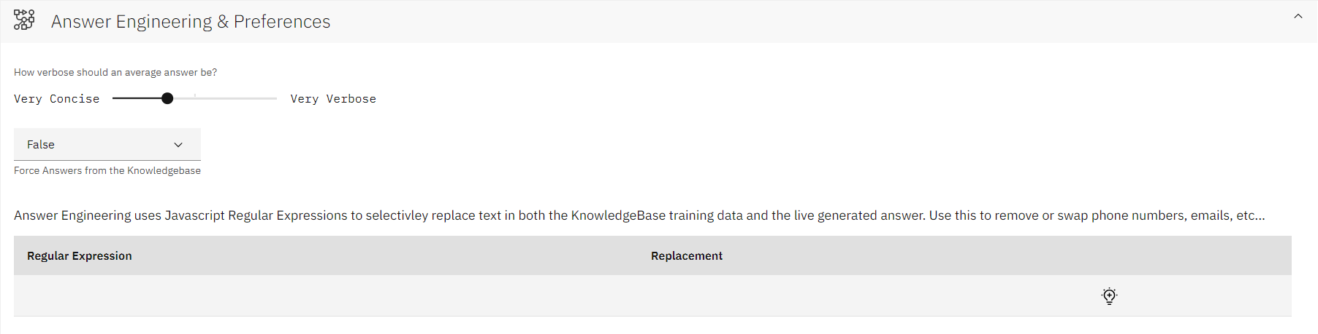
Figure: answer engineering preferences
REFERENCE — Values
- Answer Verbosity Utilize the sliding scales to set whether the answer generation would stick to being concise and short, or offer more freedom to be flexible and wordy.
- Force Answers from the KnowledgeBase: Enable to add extra prompting to help "force" the answers from returned documentation. Generally best to keep this enabled.
- Regular Expressions: Click the light bulb icon to add a new row. Input a regular expression and a corresponding replacement. For example, use this feature to remove or swap phone numbers, emails, etc.

Intent Matching & Cache Configuration
NeuralSeek automatically generates and groups user input into intents. When a user input does not match an existing intent, the question is added to the generic FAQ group.
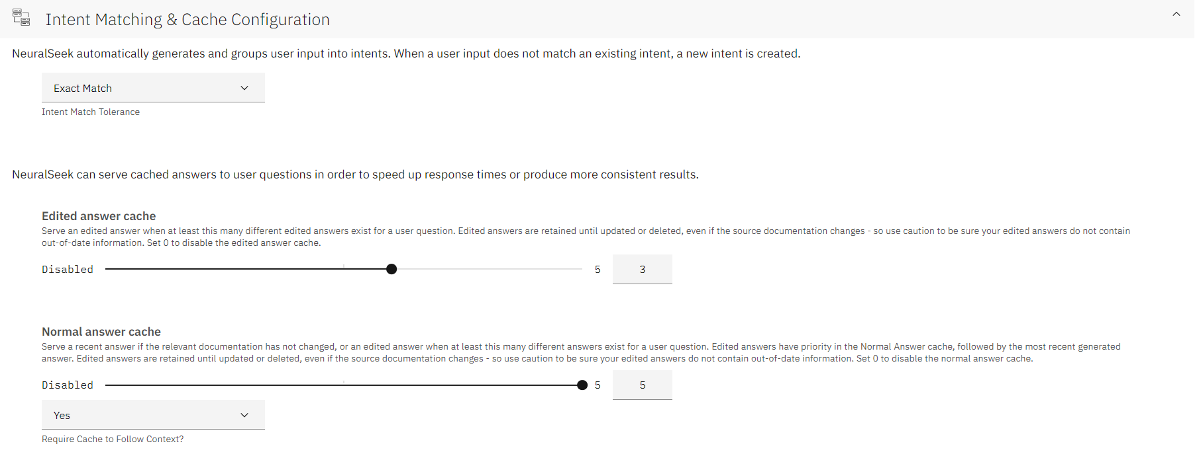
Figure: intent matching cache config
REFERENCE — The following types of intent matches are available:
- Exact Match: The user input exactly matches an intent.
- Vector Similarity: Compare the vector similarity of the user input to existing intents, matching with similar intents.
- Utilize the "Try it Out" feature to test intent similarity. Input an example sentence and click the 'Test' button. The output will show similar intent pulled from the Curate tab and a corresponding similarity score.
- Utilize the "Intent Match Threshold" sliding scale to set the minimum match percentage to match an existing Intent.
- Fuzzy Match: The user input closely matches an intent, but not exactly.
- Keyword Match: The user input contains keywords that exactly match keywords in an intent.
- Fuzzy Keyword Match: The user input contains keywords that closely match an intent.
Users can also configure how the answer caching is to be done for edited answers, and normal answers. This is useful for speeding up response times and producing more consistent results.
REFERENCE — Values
- Edited Answer Cache: Define the minimum amount of edited answers before language generation stops, and cached answers are served. Set the scale to '0' to disable the edited answer cache.
- Normal Answer Cache: Define the minimum amount of normal language generated answers to store before language generation stops, and cached answers are served. Set the scale to '0' to disable the edited answer cache.
- Warning: Remember Edited answers have priority in the Normal Answer Cache, followed by the most recent generated answer.

Secrets
Store secrets for use in mAIstro flows to protect sensitive data from view. Secrets you set here will be available as variables in mAIstro. Be sure to escape any double quotes in your Value with a backslash.
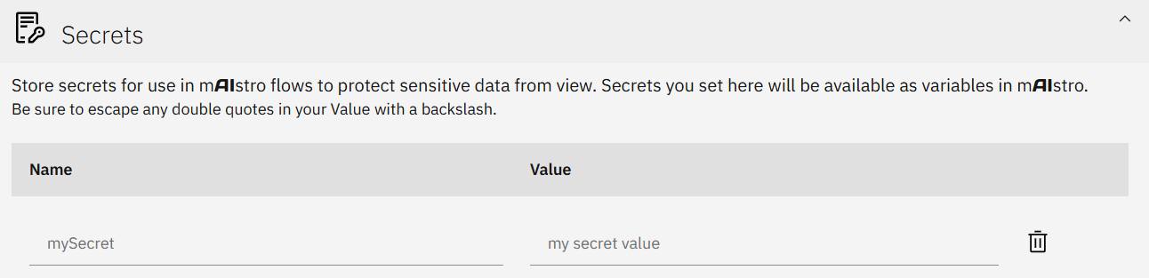
Figure: secrets
REFERENCE — Values
- Name: Name of your secret value.
- Value: A variable that you want hidden from public view. Whenever this value is called, it will only be displayed as what you have set as its Name.
EXAMPLE — Example
Suppose you have a Slack API code that you want to use in your mAIstro templates. Using Secrets, you can input the API code, while listing its name as simply "slack"
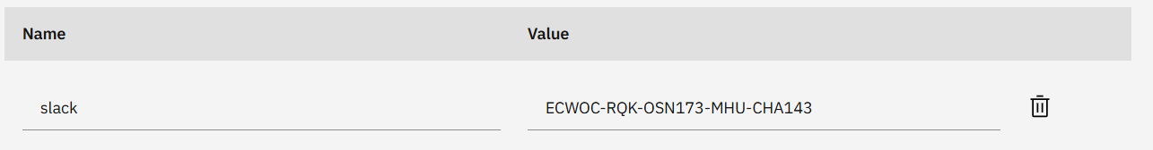
Figure: slack-code
Once you save the updated configuration and head over to mAIstro, you'll be able to locate the slack API code, under its "slack" secret name, by clicking on the secrets tab in a blank text box
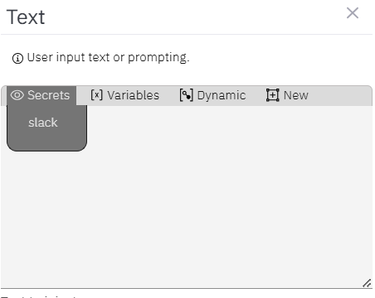
Figure: slack-maistro

Table Understanding
This pre-processes your documents to extract and parse tabular data into a format suitable for conversational query. Since this preparation process is both costly and time-consuming, this feature is opt-in and will consume 1 seek query for every table preprocessed. Web Crawl Collections are not eligible for table understanding, as the re-crawl interval will cause excessive compute usage. Table preparation time takes several minutes per page. Please contact cloud\@cerebralblue.com with details of your opportunity and use case to be considered for access.
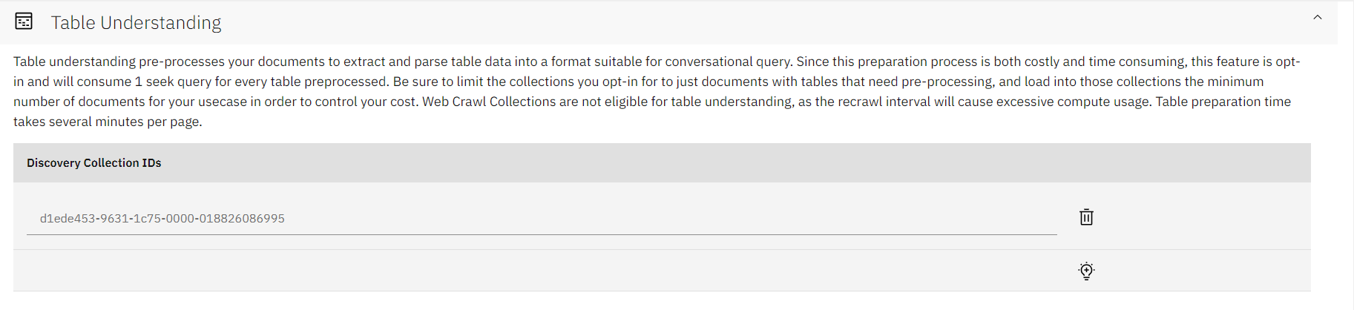
Figure: table understanding
REFERENCE — Values
- Discovery Collection IDs: Click the light bulb icon to add a new row. Input the desired collection ID from Watson Discovery for table preparation.
NOTE
Table Understanding requires a compatible LLM with Table Understanding Enabled. Not all LLMs are capable of Table Understanding.

Part 2 — Guardrails
Guardrails govern what NeuralSeek allows in (user input), what it allows out (generated answers), and how it scores its own confidence. Each guardrail can be set globally or per category when Multi-Agent Routing is enabled.

Guardrails
Settings related to governance, prompt protection, profanity filtering, etc. have been separated into their own node when Multi-Agent Routing is enabled.
Guardrails are available at every level of the tree with a custom configuration, and allow users better control of their category-based configurations.

Semantic Scoring
Toggle the icons to enable or disable the Semantic Score Model, using Semantic Score as the basis for Warning & Minimum confidence (e.g. Do NOT Enable for use cases requiring language translation), re-ranking the search results based on the Semantic Match, and checking the document titles and URL's as part of the Semantic Match. Note that semantic scoring will not be accurate when getting answers in a different language than your KnowledgeBase source docs.
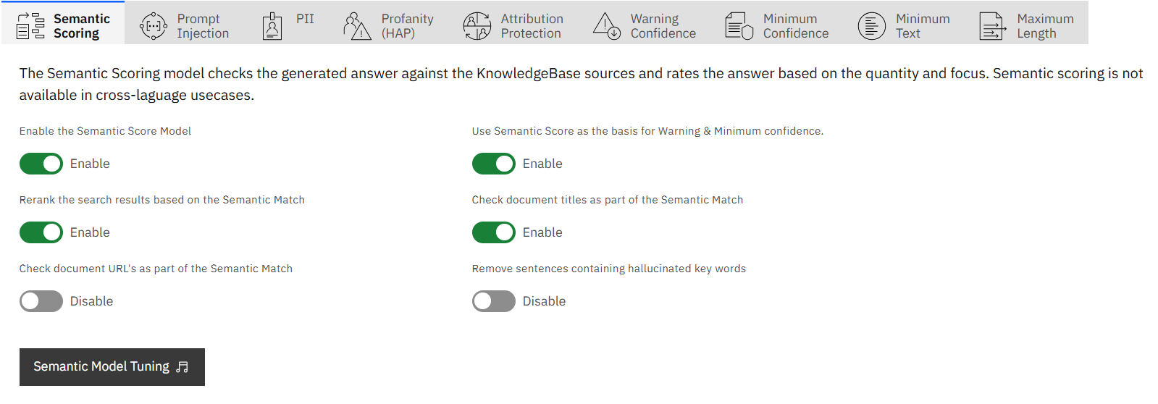
Figure: semantic score
REFERENCE — Values
- Enable the Semantic Score Model: The Semantic Score model compares the generated answer against the KnowledgeBase sources, and rates the answer based on the quantity and focus of matches to the KnowledgeBase and Stump Speech source documentation (e.g. is the answer primarily formed from a single source or many?)
- Use Semantic Score as the basis for Warning/Minimum: Enabling this uses the Semantic Score for warning/minimum confidence settings. Disabling will use the KB confidence % instead. Not recommended for non-English use-cases
- Re-rank search results based on Semantic Match: Re-order the KnowledgeBase documentation snippets based on how well the passage matches the answer given.
- Check document titles as part of the Semantic Match: Include the document title while calculating the Semantic Match Score.
- Check document URLs as part of the Semantic Match: Include the document URL while calculating the Semantic Match Score.
- Remove sentences containing hallucinated key words: Remove key words not contained or related to the KnowledgeBase.
REFERENCE — Semantic Tuning Model
Use the sliding scales to further tune the Semantic Match.
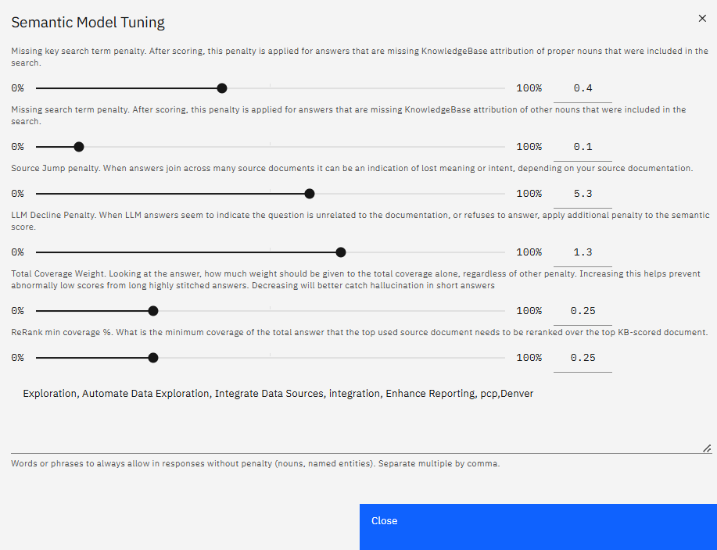
Figure: semantic model tuning
- Missing key search term penalty: After scoring, this penalty is applied for answers that are missing KnowledgeBase attribution of proper nouns that were included in the search.
- Missing search term penalty: After scoring, this penalty is applied for answers that are missing KnowledgeBase attribution of other nouns that were included in the search.
- Source Jump penalty: When answers join across many source documents it can be an indication of lost meaning or intent, depending on your source documentation.
- Total Coverage weight: Looking at the answer, how much weight should be given to the total coverage alone, regardless of other penalty. Increasing this helps prevent abnormally low scores from long, highly-stitched answers. Decreasing will better catch hallucination in short answers.
- Re-Rank Min Coverage %: What is the minimum coverage of the total answer that the top used source document needs to be re-ranked over the top KB-scored document.
- Words or phrases to allow: Always avoid penalty for selected words or phrases in reponses.

Prompt Injection
Users are able to block malicious attempts from users trying to get the LLM to respond in disruptive, embarrassing, or harmful ways.
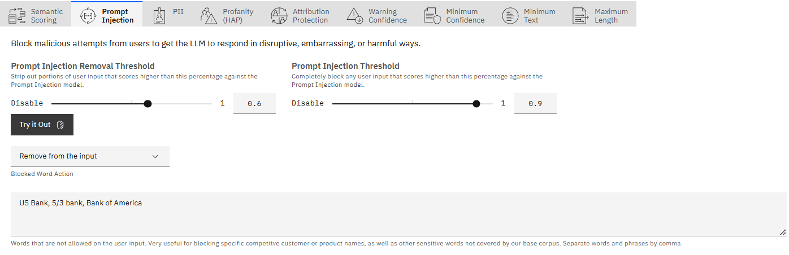
Figure: prompt injection mitigation
REFERENCE — Values
- Prompt Injection Removal Threshold: A sliding scale to strip out portions of user input that exceed this specified percentage against the Prompt Injection model, allowing partial input filtering without blocking the entire prompt.
- Prompt Injection Threshold: A sliding scale to block any inputs that score higher than this percentage against the Prompt Injection model.
- Blocked Word Action: Either remove the offending words from the user input, or block the question altogether.
- Blocked Word List: Enter words or phrases (separated by commas) that are not allowed on the user input. This is useful for blocking specific competitive customer or product names, as well as other sensitive words not covered by NeuralSeek's base corpus.

Personally Identifiable Information (PII)
Users can define how to handle any detected PII data that was included in the question.
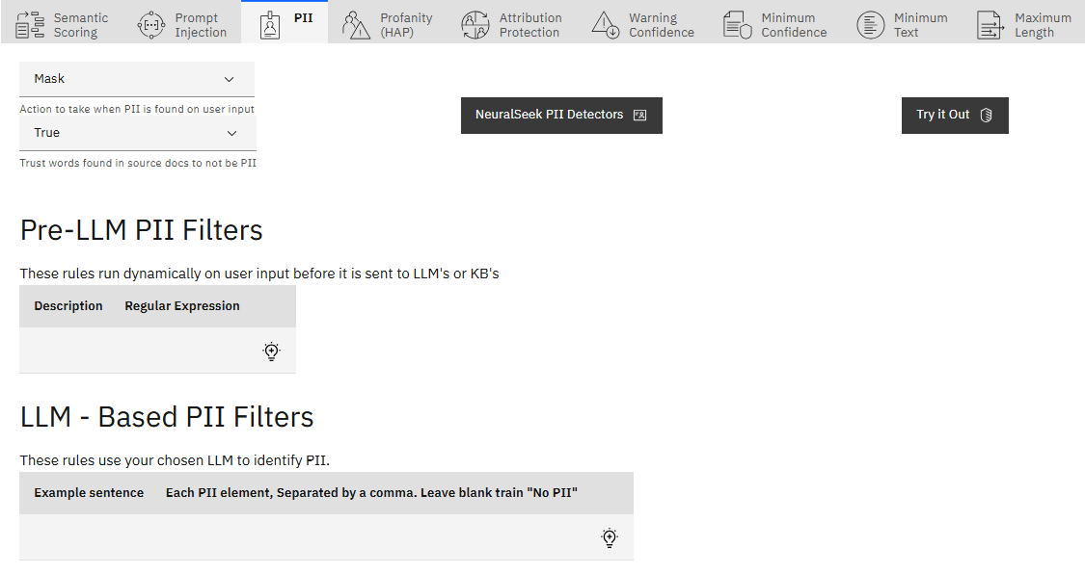
Figure: pii
REFERENCE — Values
- Action to take: Specify actions when PII is detected:
- Mask: Mask, and store, PII when it is detected in the user input. Masking will hide the PII in all locations.
- Flag: Flag, and store, for PII when it is detected in the user input. PII will be flagged in all locations.
- No Action: No action will be taken when PII is detected in the user input. It will be stored in plain text.
- Hide (retain for Analytics): Hide (mask) the PII when it is detected in the user input, but keep the PII in the database for Analytics.
- Delete (including from Analytics): Delete the PII entirely when it is detected in the user input, including from the stored Analytics.
- Trust words found in source docs: Indicate if certain trusted terms in source documents should be acknowledged or ignored.
- Pre-LLM PII Filters: These run dynamically on user input before it is sent to the LLM or KnowledgeBase. Click the light bulb icon to add a description such as a phone number and a corresponding regular expression.
- LLM-Based PII Filters: These use the chosen LLM to identify PII. Click the light bulb icon to add an example sentence and corresponding PII elements, separated by commas.
- NeuralSeek PII Detectors: Select the default NeuralSeek detectors to capture PII.
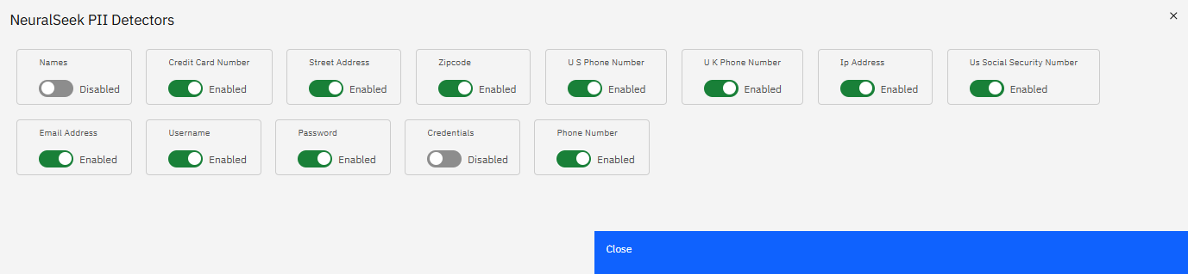
Figure: neuralseek pii detectors
NOTE
Utilize the "Try it Out" feature to test the set PII filters. Input an example sentence and click the 'Test' button. The output will show the test sentence, a true or false response if PII was detected, and what element of the sentence was detected as PII.
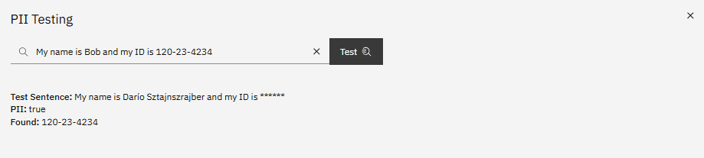
Figure: pii testing

Profanity (HAP)
Users are able to enable or disable the profanity filter, as well as add a text to reply with for sensitive questions that are blocked.
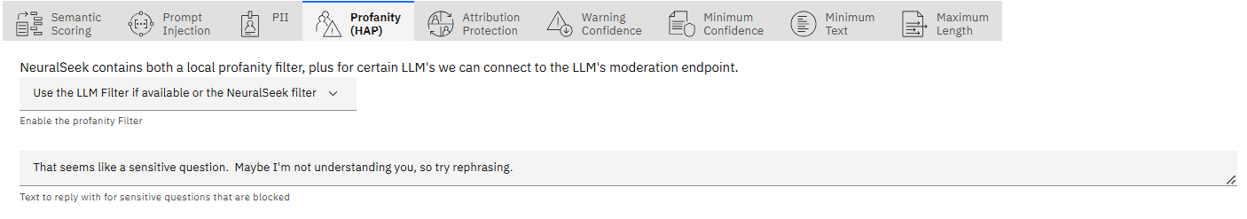
Figure: profanity filter
REFERENCE — Values
- Enable profanity filter: Choose which filter to use for profanity filtering. You may use the LLM's moderation endpoint if available, the NeuralSeek Filter, or disable it.
- Blocked reply text: The text to show when the input or question is blocked. E.g. "That seems like a sensitive question."

Attribute Protection
Adjust misinformation tolerance for generating text about the company, or associating people or things that lack specific references in the KnowledgeBase material by using the sliding scale from "Rigid" to "Standard". The more rigid your settings, the higher the chances of occasionally blocking legitimate questions that use alternate wording or are poorly documented in your KnowledgeBase.
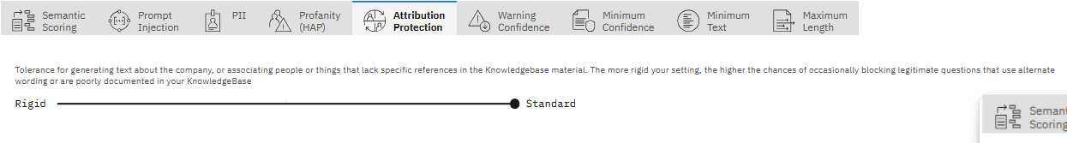
Figure: attribution protection

Warning Confidence
Use the sliding scale to increase the confidence threshold.
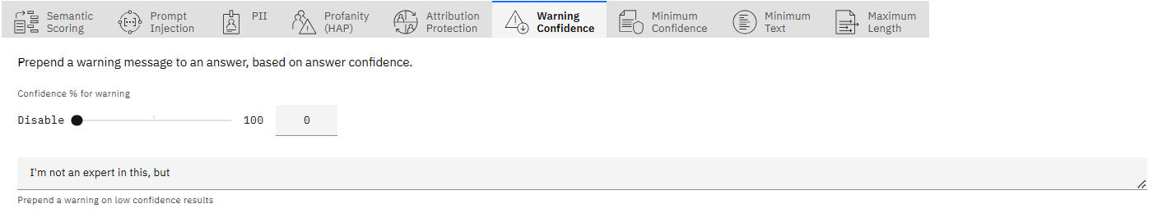
Figure: warning confidence
REFERENCE — Values
- Confidence %: Any answers lower than this number will have the below text pre-pended to the answer given.
- Warning text: The text to pre-pend to the answer given.

Minimum Confidence
Use the sliding scale to increase the minimum confidence percentage and the minimum confidence percentage to display a URL. Add a text to reply with for questions not meeting the minimum confidence, and select whether to add a URL fallback on minimum. (e.g. "There is nothing in our knowledge base about that.").
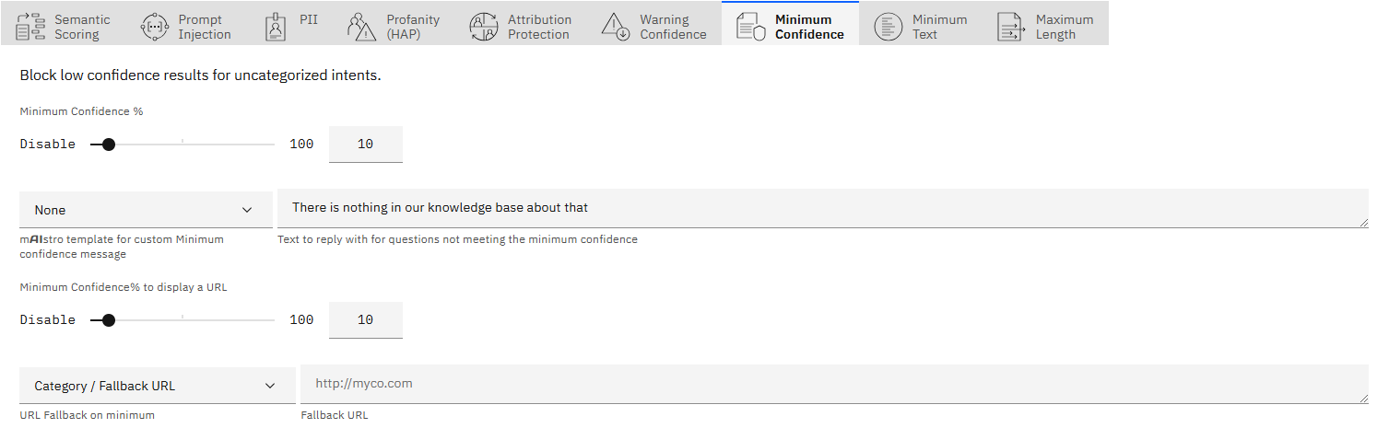
Figure: min confidence
REFERENCE — Values
- Minimum Confidence %: Any answers lower than this number will have the below text substituted in place of the answer.
- mAIstro template Optional - A mAIstro template to handle minimum confidence in a customized way.
- Reply text: The response to give when answers are below the minimum confidence % set.
- Minimum Confidence % to display a URL: Any answers lower than this number will not return a linked URL.
- URL Fallback Optional - A URL to offer when the minimum confidence is not met.
EXAMPLE — Minimum Confidence with mAIstro Fallback
Use the mAIstro template to set up a fallback plan for cases where the confidence threshold is not met. This ensures a seamless transition to a more suitable response or action, like notifying teams or escalating the issue.
- Create a mAIstro template: Build a fallback template for handling low-confidence scenarios. In the 'Min Confidence - IN' node (which should be positioned at the top), define the logic for how it should respond.
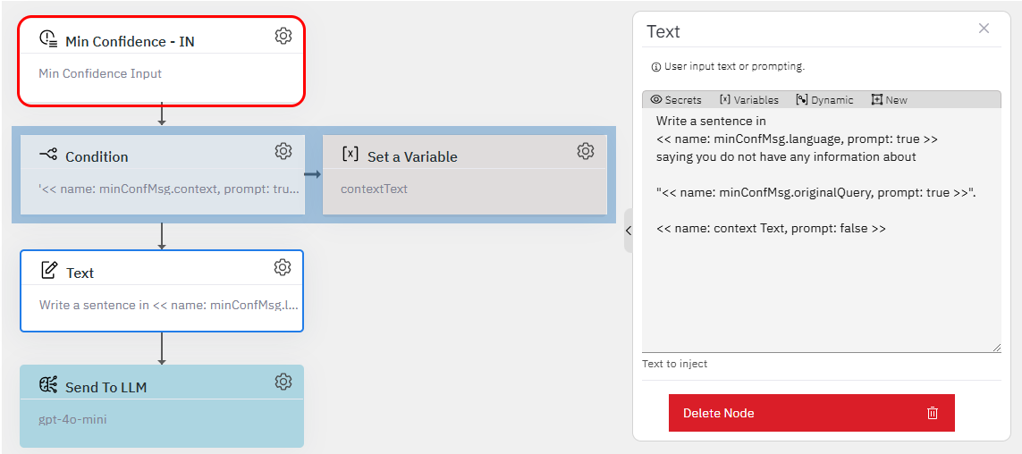
Figure: min confidence template
- Select your template: Once your template is ready, select it in the 'mAIstro template for custom Minimum Confidence message' dropdown.
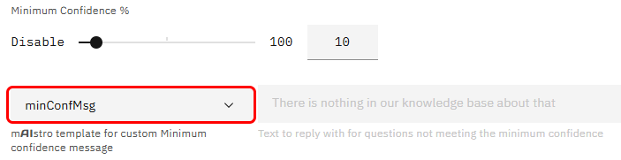
Figure: select template
- Test with out-of-scope queries: After setup, try asking a question that's out of the knowledge base. Seek will default to your new template. Play around with it and see how it handles fallback scenarios!
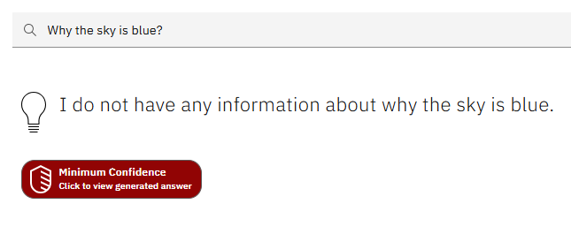
Figure: seek fallback
- Notify via Slack: If an out-of-scope question is asked, notify your team on Slack so they can improve the documentation for future use.
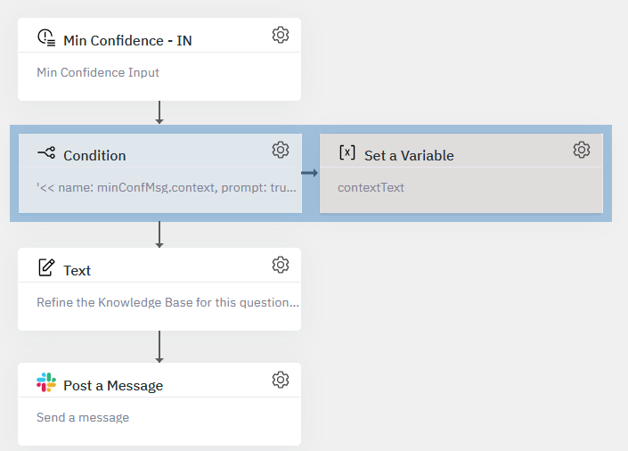
Figure: slack template
- Create an Issue in GitHub: Automatically create a GitHub issue with details like minConfMsg.originalQuery and minConfMsg.language.
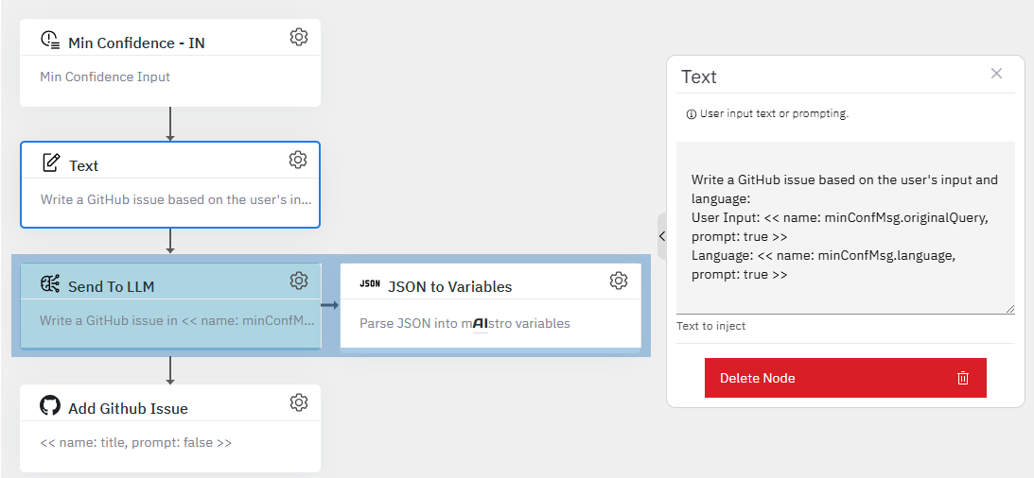
Figure: github template

Minimum Text
Use the sliding scale to set a desired minimum amount of words in a question.
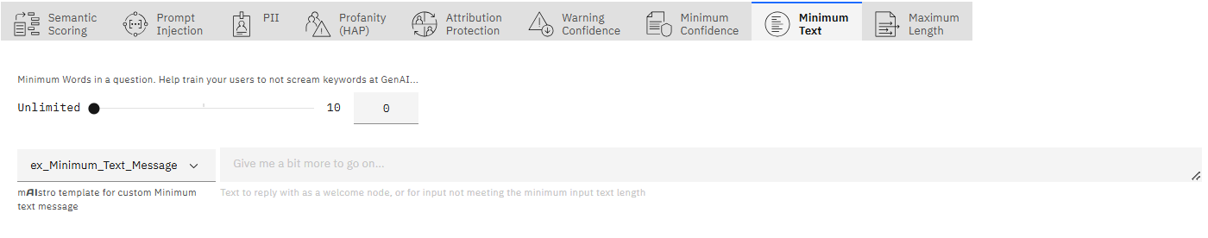
Figure: min text
REFERENCE — Values
- Minimum Words: The minimum number of words in a user question/input.
- mAIstro template Optional - A mAIstro template to handle minimum text in a customized way. In this case we need to use the 'Min Text - IN' node and you can try template flows as in the 'Minimum Confidence' section.
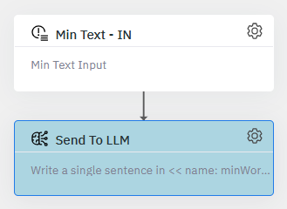
Figure: min text template
- Reply Text: Add a text to reply with for questions not meeting the minimum input word length. (e.g. "Give me a bit more to go on\...").

Maximum Length
Use the sliding scale to set a desired maximum amount of words in a question.
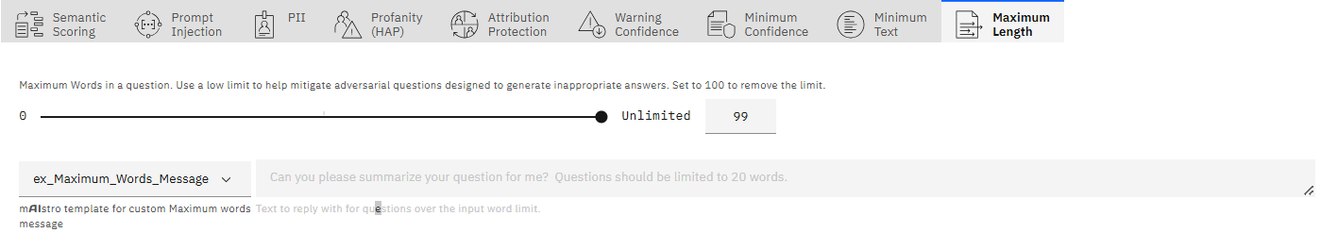
Figure: max length
REFERENCE — Values
- Maximum Words: The maximum number of words in a user question/input. Set to 100 to remove the limit. Use a low limit to help mitigate adversarial questions designed to generate inappropriate answers.
- mAIstro template Optional - A mAIstro template to handle maximum text in a customized way. In this case we need to use the 'Max Words - IN' node and you can try template flows as in the 'Minimum Confidence' section.
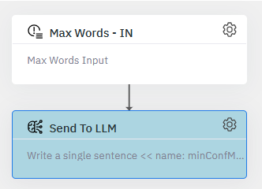
Figure: max text template
- Reply Text: Add a text to reply with for questions over the input word limit. (e.g. "Can you please summarize your question for me? Questions should be limited to 20 words.").

